# **Principal of Object Oriented Programming**

## **Abstraction**

TV switch on and off. Operating car via brakes and accelerate.  
Don’t know the operation of how the machine performs.

## **Encapsulation**

All the wires, transistor, vehicle engine are encapsulated.

## **Inheritance**

### **Specialization**

### **Generalization**

Eg-1 🡪Suppose, You learn to drive a car then you can able drive any car. Not learning separately to drive Toyota, Suzuki, Hyundai cars separately.

Eg-2 🡪 Students, all the students will turn towards the faculty.

Eg-3 🡪 Red traffic light, all the cars stops.

## **Polymorphism**

# **Class vs Objects**

Objects 🡪 real world  
Class 🡪 only in paper

Properties as variables  
Behaviours as methods

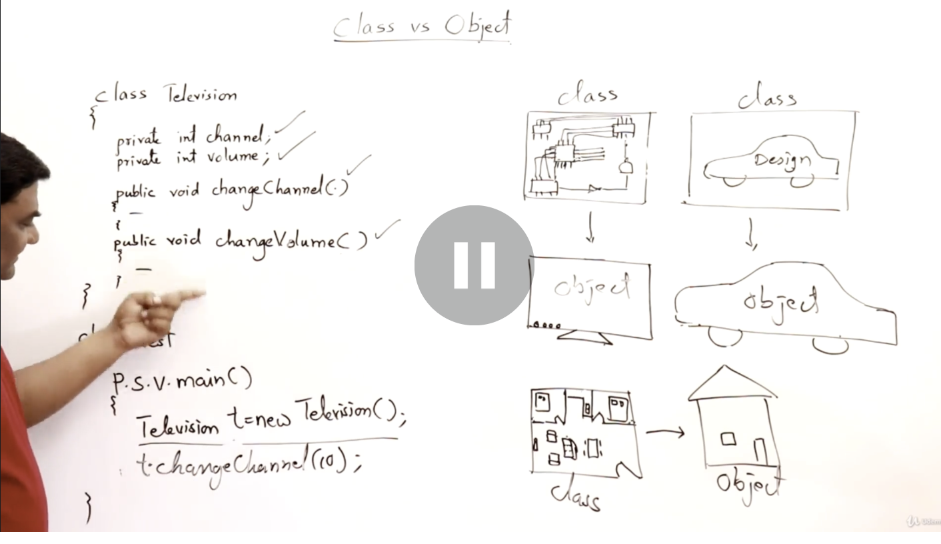

# **How to write a class ??**

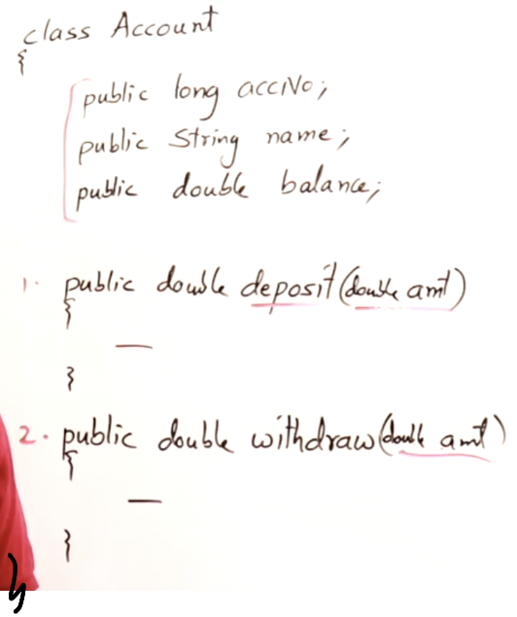

# **Data Hiding**

Usually data is hidden and only the methods are visible.   
The methods will do the operations based on that hidden data.

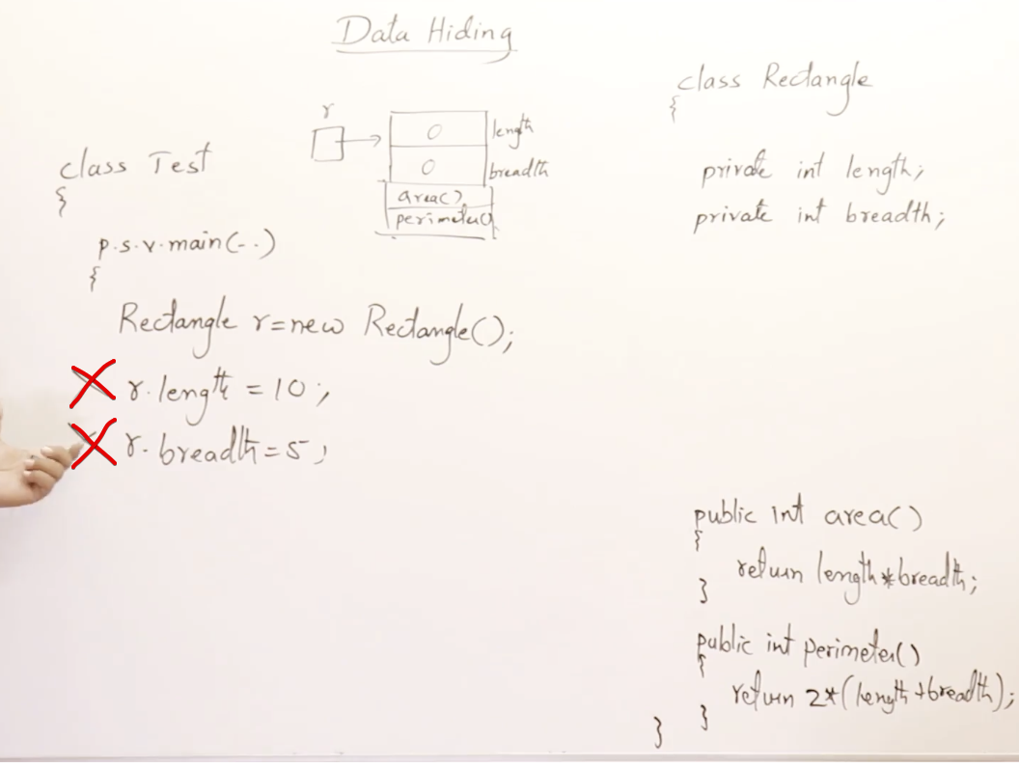Length and breadth are not accessible outside the class since they are private.

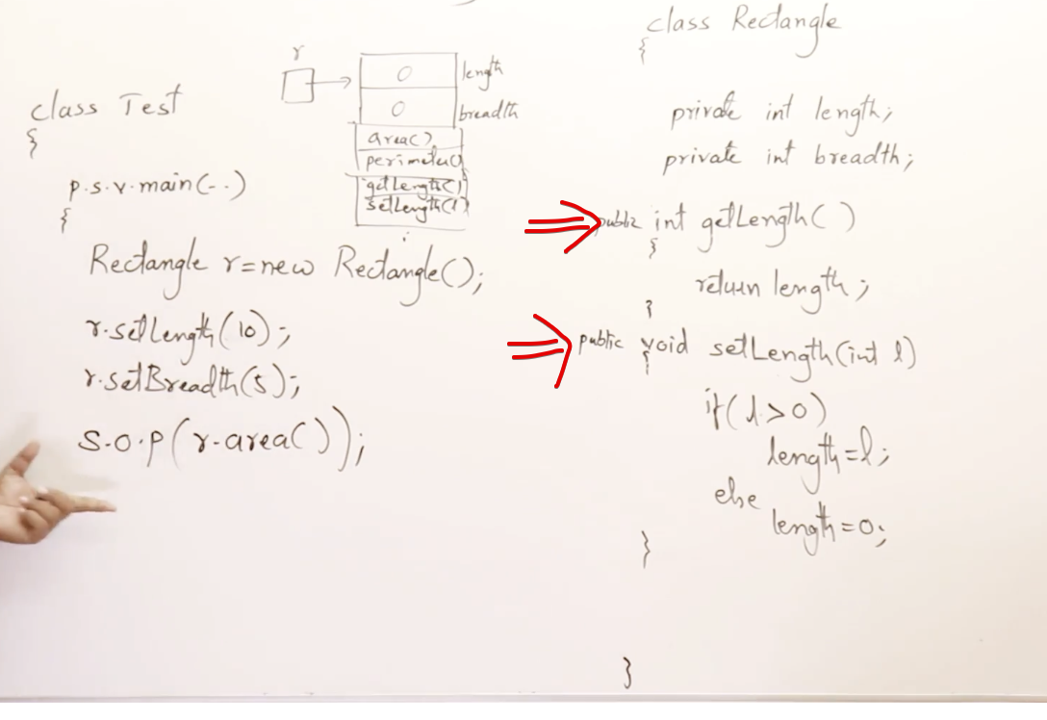

# **Concrete class and Abstract class**

Concrete class 🡪 objects can be created  
Abstract class 🡪 objects cannot be created

But reference for the abstract classes are allowed

Abstract class  
Abstract method

When a abstract function should have no body  
(i.e) abstract void method();

An abstract class can have 0/more abstract methods

